Driver Install

Download the appropriate driver:
- Go to Start Menu and right click on Computer then click on Properties.

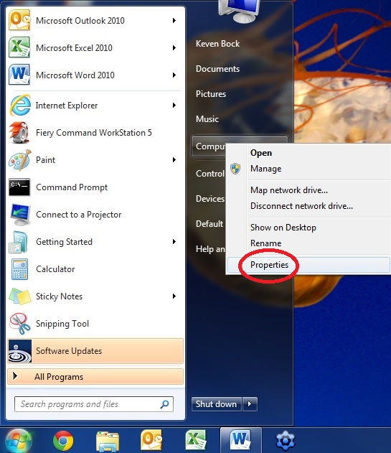

- Look under the Windows edition and System type headings to determine your operating system. Some examples are Windows 7 64 bit, Windows 7 32 bit, Windows Vista 64 bit, etc.
*Note: If 64 bit or 32 bit is not specified the Operating system is 32 bit.*

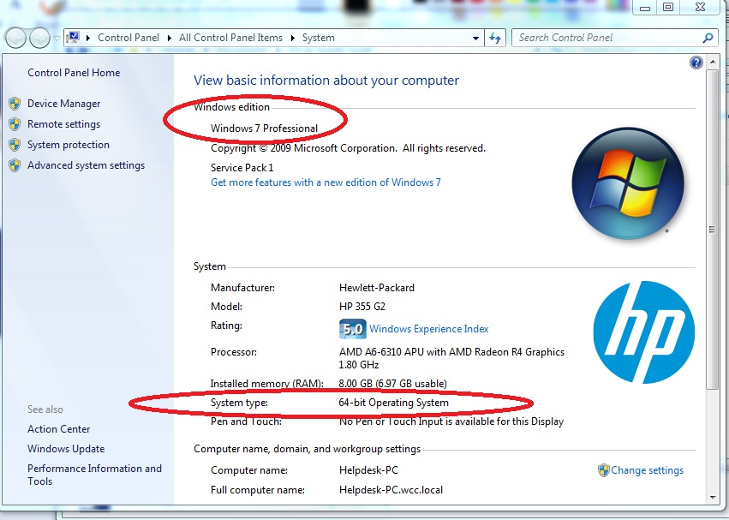

- Once you have determined what operating system you have, go to www.Lanier.com and click Downloads, then click Agree and Submit.

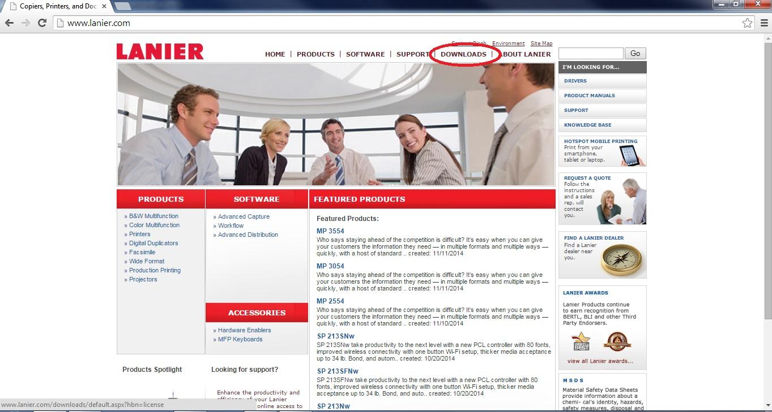

- Select your device from the dropdown menus. (MP C2003 used here for example)

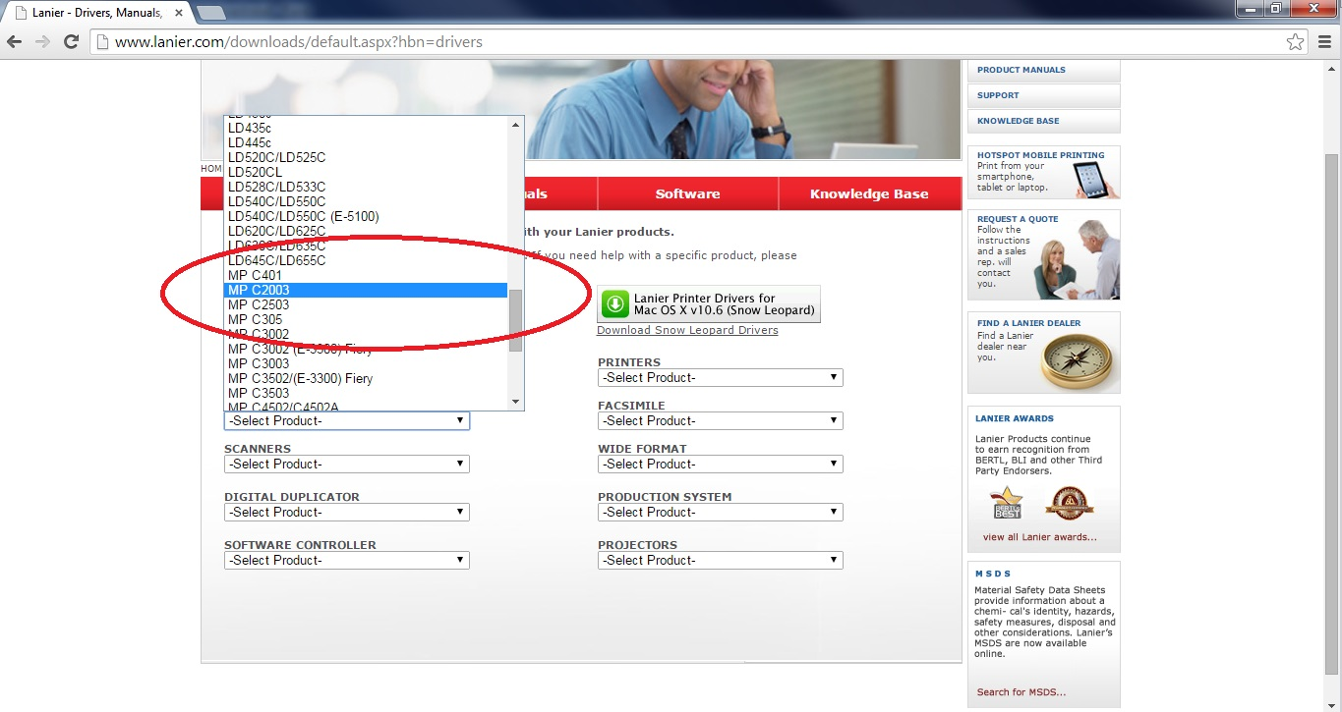

- Select your operating system determined in Steps 1 and 2 (Windows 7 64 bit used here for example)

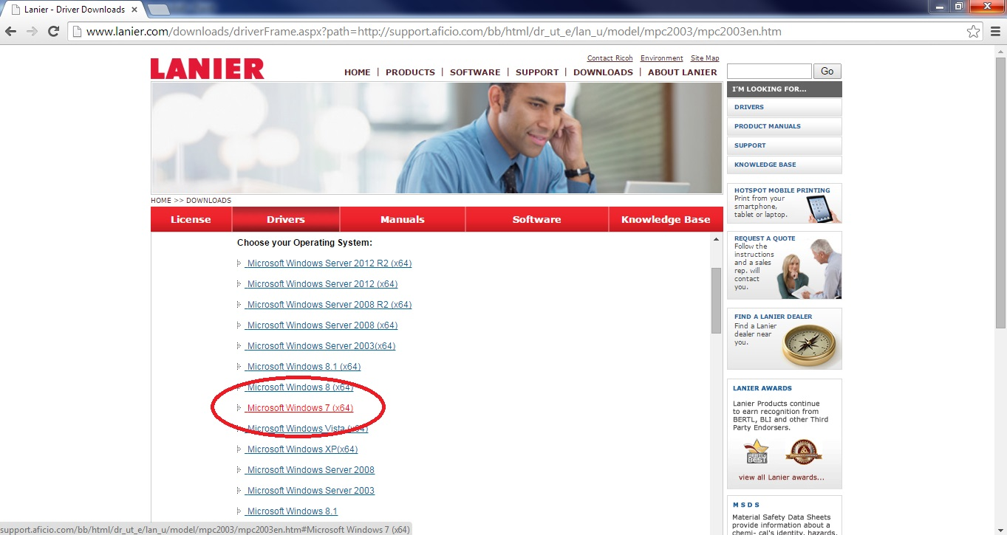

- Find the PCL 5 driver for your operating system and click the Download arrow on the right.

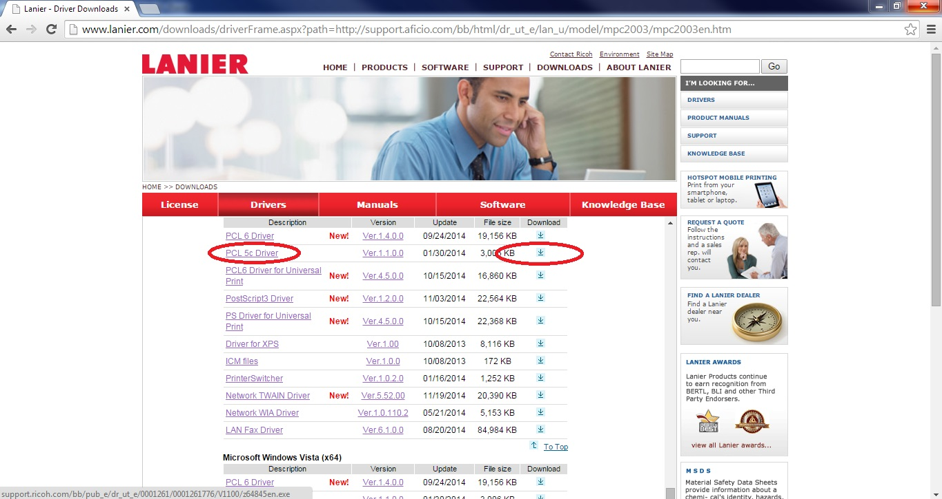

- Depending on your browser click Run or click on the download file that pops up in your window and then click Run.

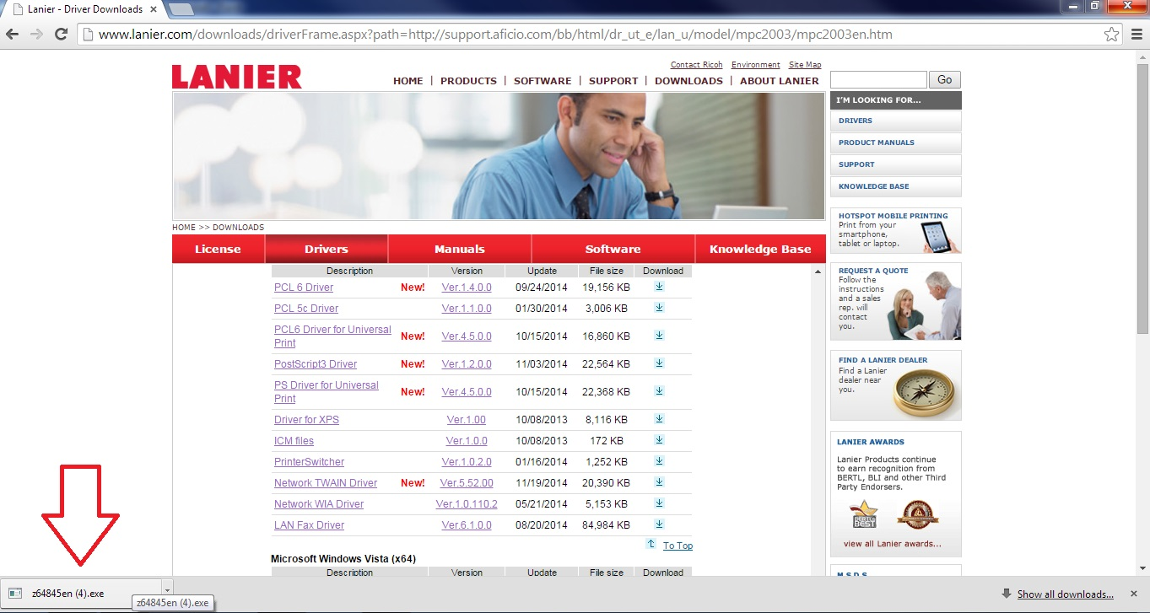

- Click Next. Then Browse( 1) and select Desktop (2 -usually at the top of the list). Then click OK (3). Then click Next (4)again. Click OK again. This will download the file to your Desktop.

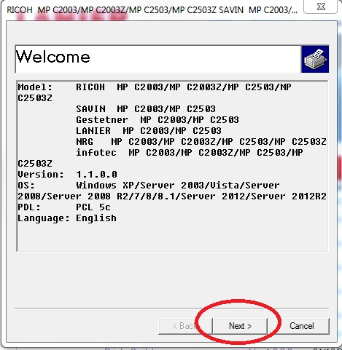
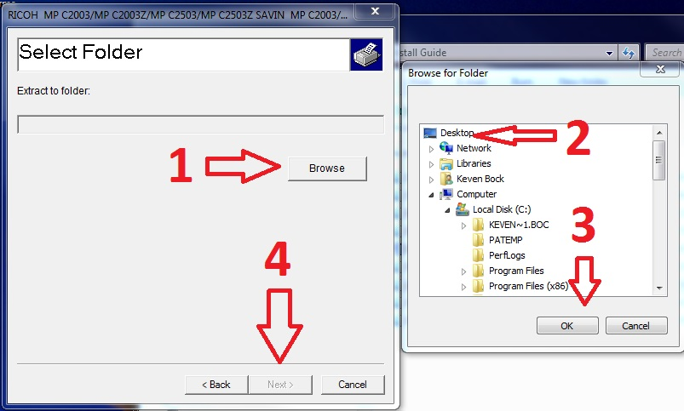

Adding the Printer and Installing the Driver:
- Go to the Start Menu and click on Control Panel.

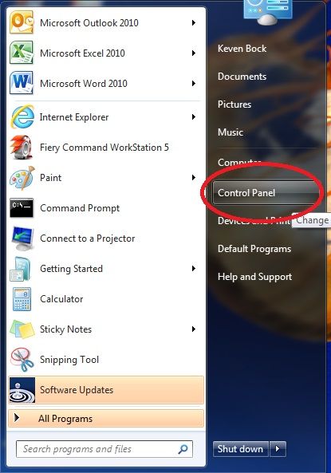

- Navigate to and click on Devices and Printers. Older operating systems may just say Printers.

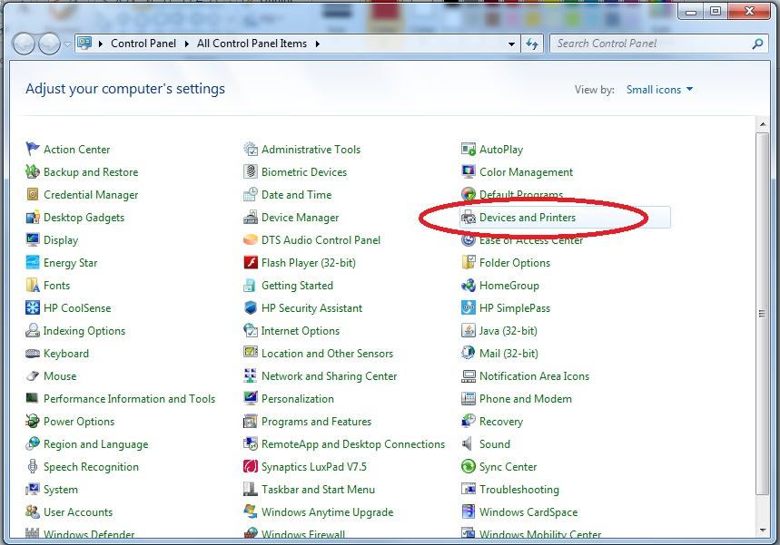

- Click Add a Printer. This action can also be completed by right clicking in the white area.

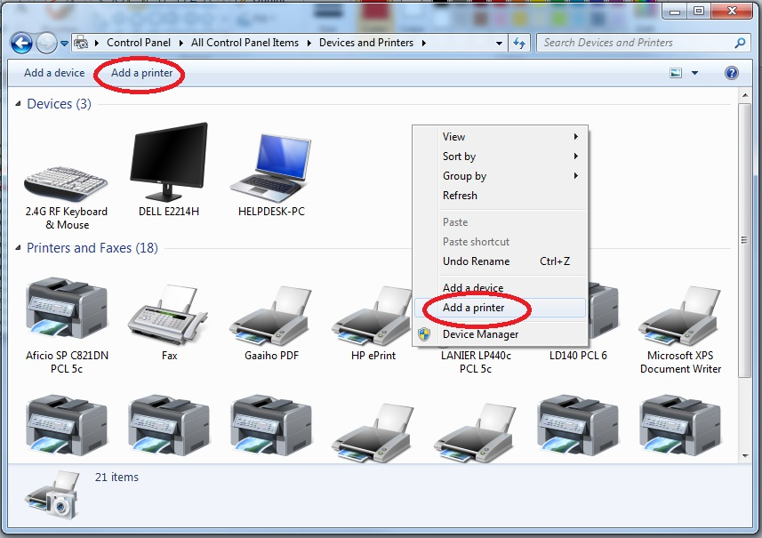

- Click Add a local printer.
IMPORTANT: If installing a brand new machine, see a)
If installing a replacement machine, see b)

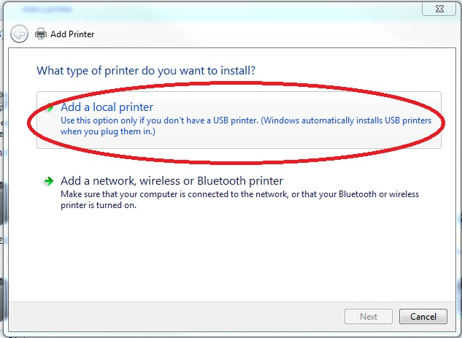

- Click Create a new port: and select Standard TCP/IP Port. Then click Next. Input your device’s IP address then click Next. (IP 192.168.2.41 used here for example)

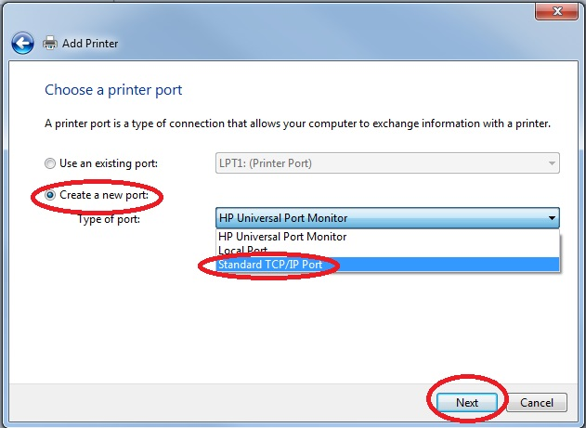
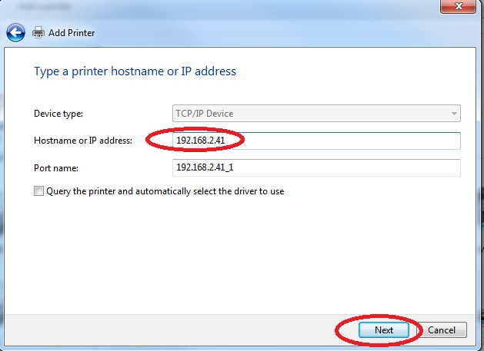

- Select Use an existing port: and select the IP address associated with your device then click Next. (IP 192.168.2.41 used here for example)

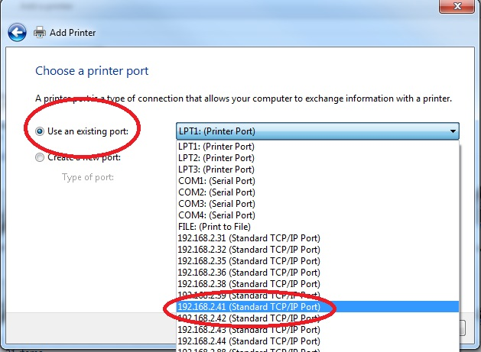

- Select Have Disk. Then click Browse. Select Desktop in the drop down menu.

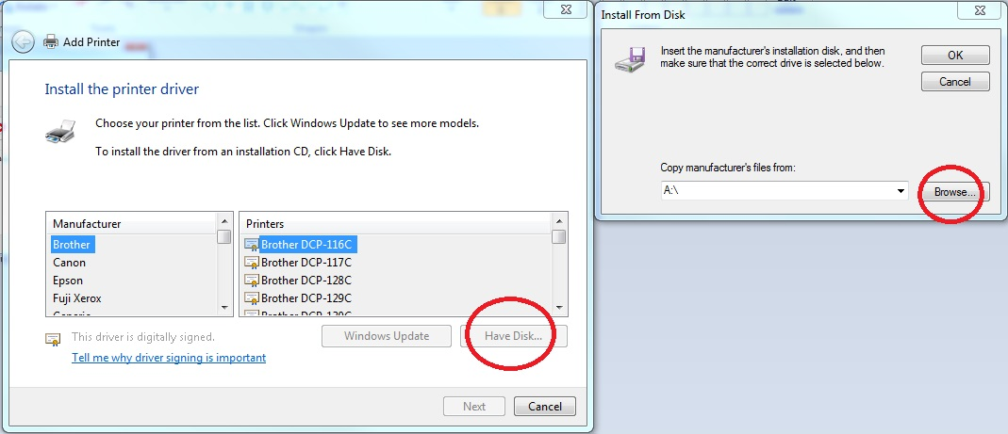

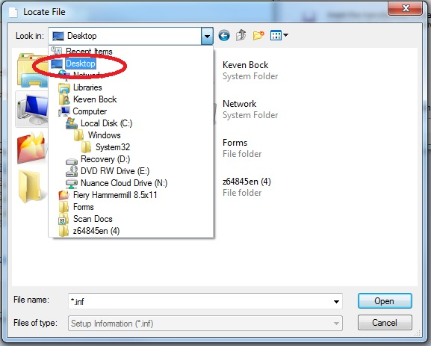

- Double click the driver download folder. Then double click disk1. Then double click OEMSETUP.

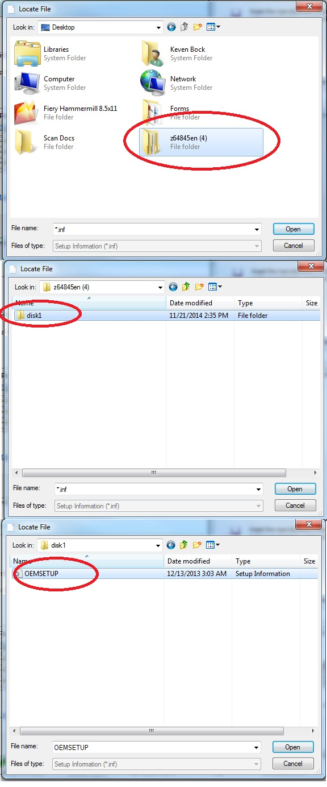

- Click OK. Then select LANIER in the Manufacturer Menu and your model printer in the Printers Menu. Then click Next. (LANIER MC C2003 PCL 5c used in this example) If you are replacing an old machine and the IP address did not change, you will get a prompt asking you if you wish to replace the current driver or use the existing one. Choose Replace the current driver.

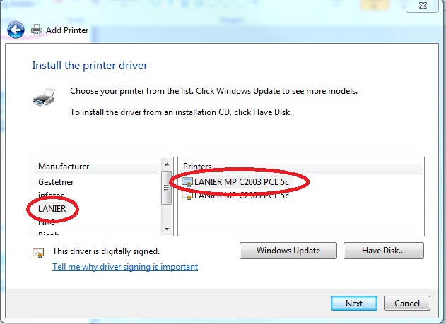

- Name your printer then click Next.
*Note: Try to keep the same name for all users throughout the office.*

- Click Do not share this printer. Then click Next. Check the Set as the default printer if you wish and then click Finish.

Setting the Printer Defaults:
- Go to the Start Menu and click on Control Panel.

- Navigate to and click on Devices and Printers. Older operating systems may just say Printers.

- Right click on your printer model and select Printer Properties.

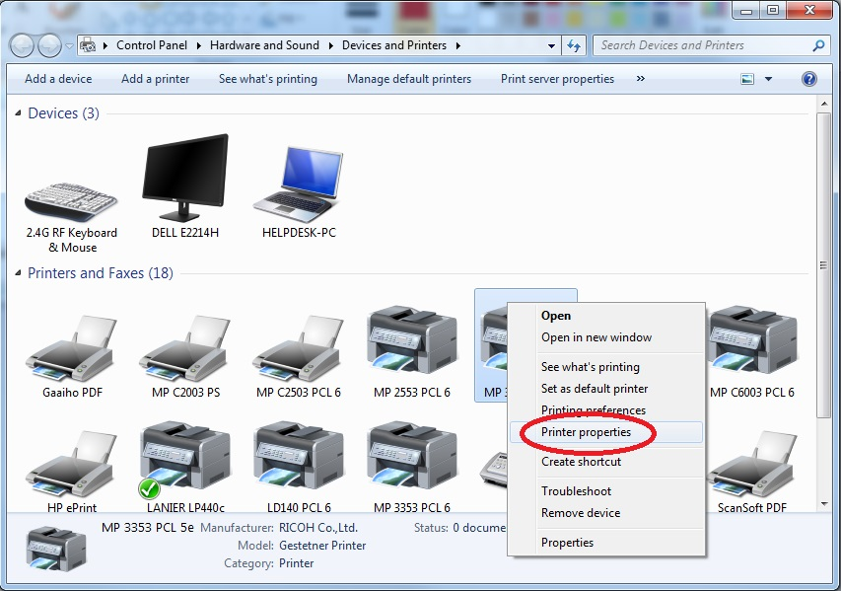

- Select the Advanced tab and click on Printing Defaults…

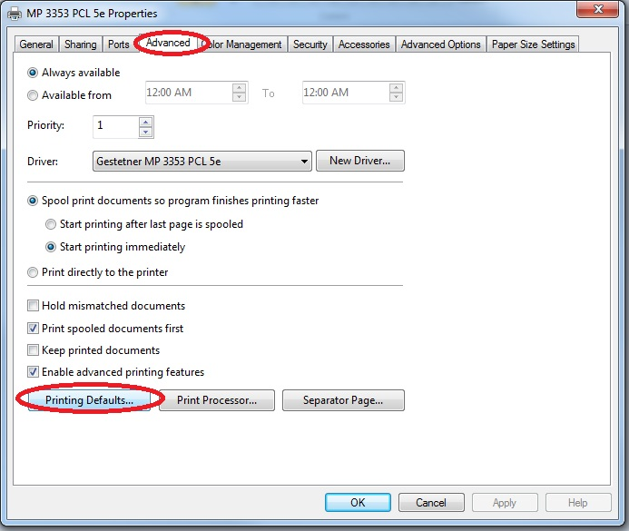

- Switch the Color setting to Black & White and switch the Duplex setting to Off. Then click Apply then click OK.
*Note: Black and White is the default because color printing usually costs more.*

