Cloud printing through email submission
Users may choose to email their print job to the Ricoh Print Cloud service.

Email Address: print@iceprintcloud.com

The Print Cloud service will print the content of the email following an analysis of the email content. On receipt of the email into the service the email is taken apart and depending on the content different print actions are taken as follow:

• If the mail starts with a URL that points to a supported document type the document is downloaded, converted and printed. An example could be
http://www.company.com/abc/directions.doc

• If the mail starts with a URL pointing to a webpage, the web page is rendered and printed. An example could be http://www.cnn.com

• If the mail contains an attachment which is a supported document type the document is rendered and printed.

• If the mail does not fall into any of the above categories the body of the mail is rendered and printed. An example is the typical add style mail that contains nice layout with embedded images, text etc.

Once the mail is received by the Ricoh Print Cloud service a release code is generated and mailed back to the user. The user can then use the code to print the job on printer enabled for Ricoh Print Cloud. Through the mail the user will also be able to view a preview of the print job.

The reply mail from the Ricoh Print Cloud service will be sent to the:
FROM: Print Cloud Dashboard noreply@iceprintcloud.com

Next, the users go to the MFP and Select the ICE shortcut on the home screen.
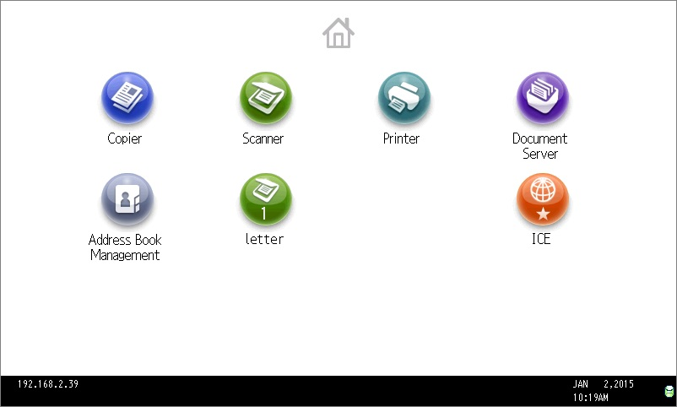
Then when the ICE Screen comes up touch anywhere.
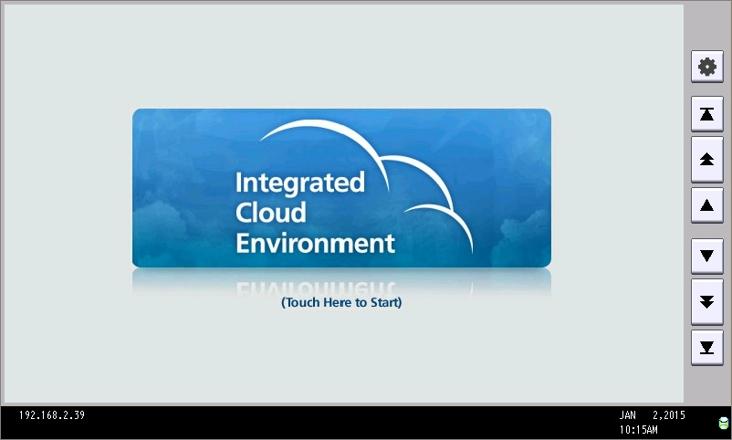
Find and select the Print Cloud App.
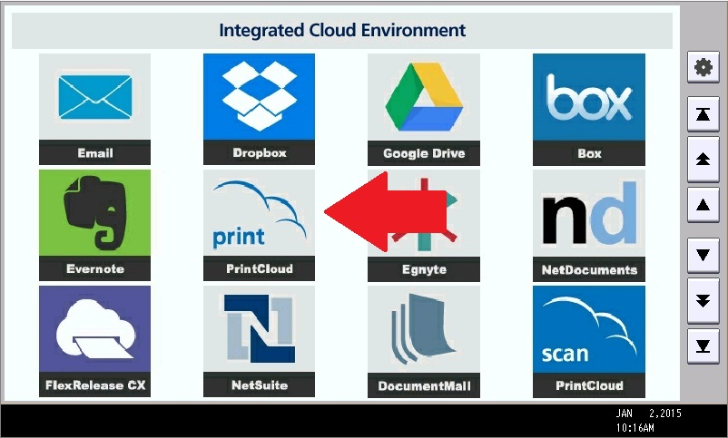
Now input your Release Code and setup your print settings and copies. When finished touch Print.
