Obtaining Printouts of Counters Per User

This Guide will instruct you on how to print out a User Counter Page from the Copier
- From the Copier Main Panel hit the User Tools/ Counter Button to bring up the User Tools Screen that looks like this.
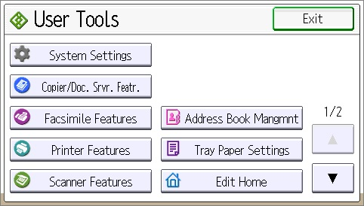
- Press the Login Hard button located near the User Tools button on the panel and that will bring up the following Screens. Your login credentials are Username: admin
Password: (leave this line blank and press ok)

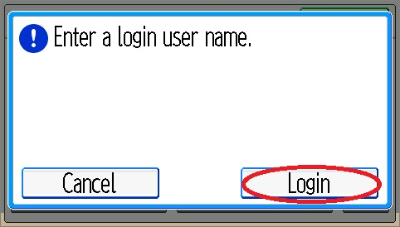

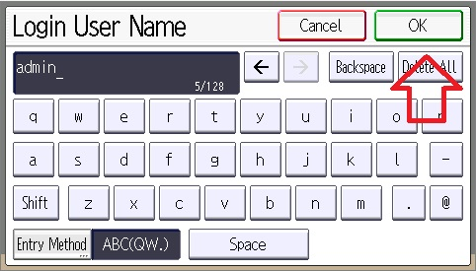

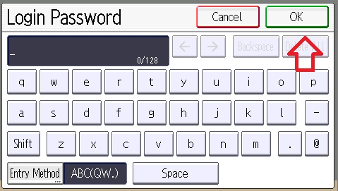

- After logging in you should see the User Tools screen again. Press System Settings to bring up the System Settings Screen.
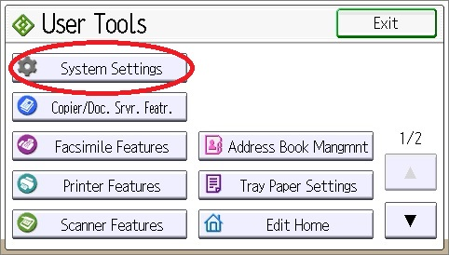
- Next hit the Administrator Tools button
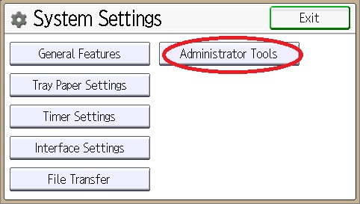

- Scroll down with the up and down arrows in the bottom right of the screen till you find the Display/Clear/Print Counter By User and hit that.
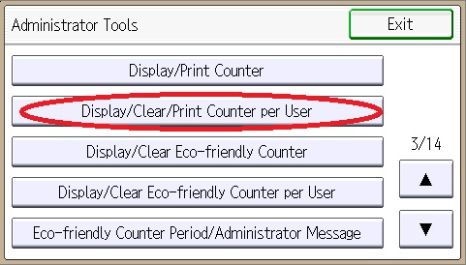
- Select any of these functions to view a count by User Code. If you are continuing to print these lists then you can select any function.
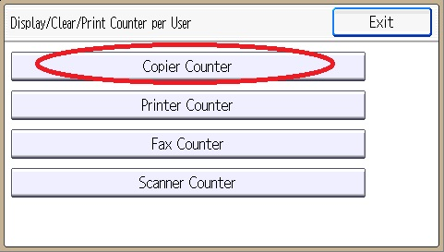

- On the display counter screen you can select users and clear or print their counter numbers. To print a list of all users hit the Print List button.
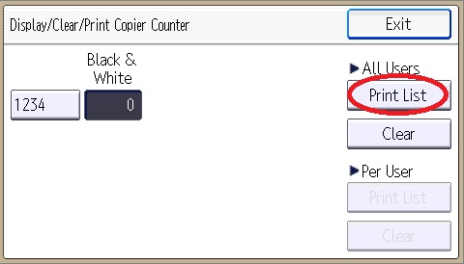
- From this screen you can select what functions you wish to print for all selected users.
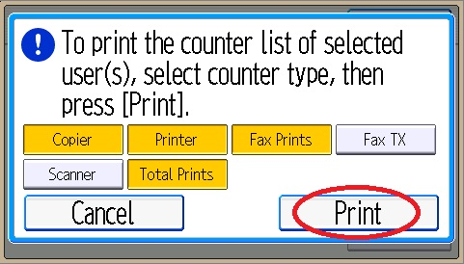
- After printing is finished hit the login/logout button and that will log you out as an administrator and return you to the home screen.

