PCL6 Printer Driver User Instructions

When printing from an application, there is an opportunity to change your printer preferences. You can change these preferences by selecting a button labeled Properties, Preferences, or Options. The following pages will explain the options you’ll find in the printer preferences window for PCL6 drivers.

- The first thing you’ll need to do is reach the printer preferences window. There are a couple ways to do this. The first is to print from an application such as Microsoft Word, Microsoft Excel, or Paint for example. The following pictures highlight where to look for the preferences button in these programs.

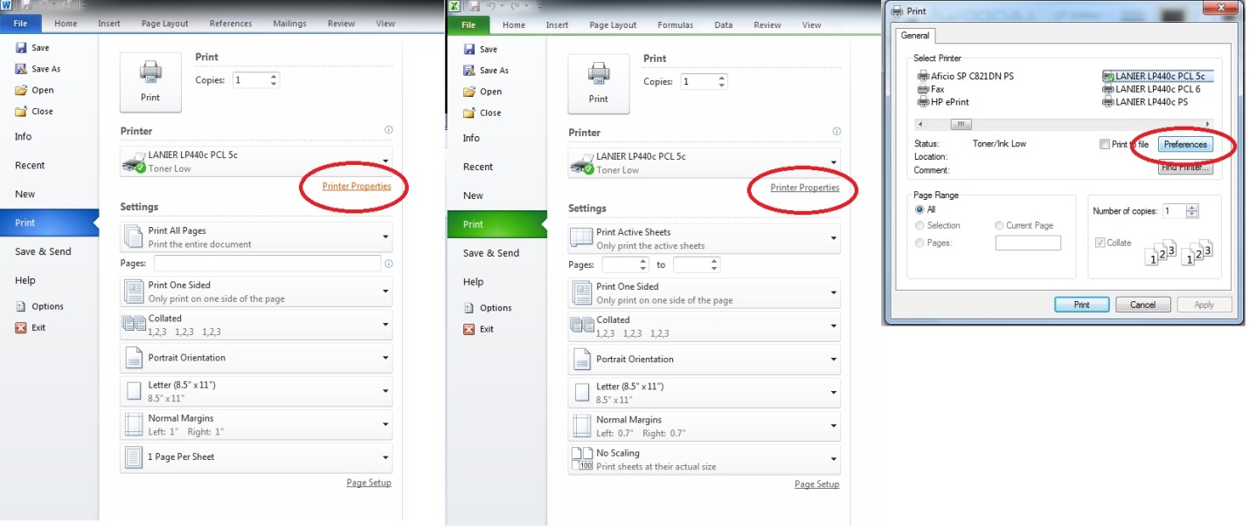

Alternatively, you can pull up the preferences for any printer by going to your Start Menu and selecting Devices and Printers and then right clicking your printer and clicking on Printing Preferences.

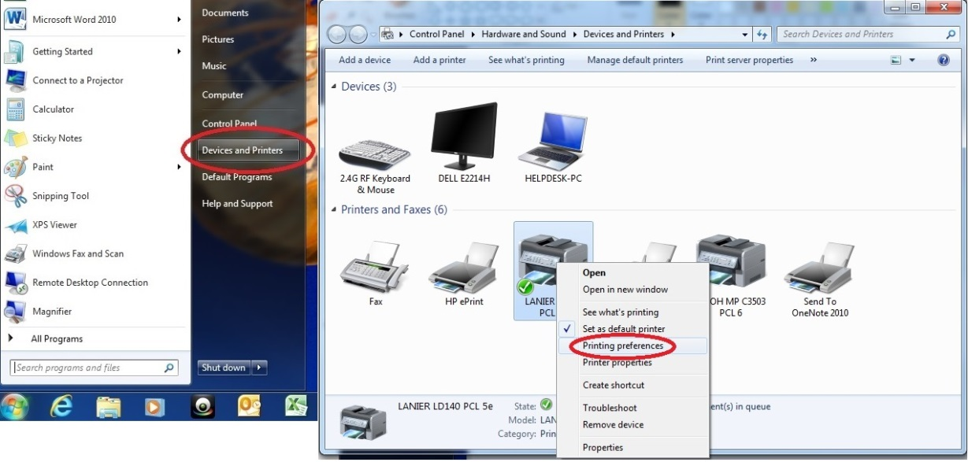

- Your Printer Preferences should then come up on the One Click Presets tab. There are a few things to note about this tab. There are preloaded default settings in your One Click Preset List window. These profiles come by default and cannot be changed. You can add a new preset by changing any of the options and clicking Register Current Settings in the bottom left corner. There is a graphic of a page in the top left corner. Whenever you change a setting this graphic will change to represent your new setting. Below the One Click Preset List window are some quick basic settings that can be changed. The Job Type setting will be covered in the next step. The other settings allow you to change Document Size, Orientation, Color/B&W, Tray Selection, Paper Type, and Copy amount.

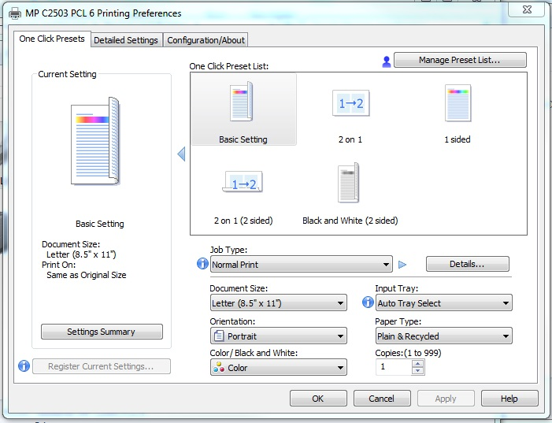

- Next let’s look at the different job types a printer can accommodate.
- The first option is Normal Print. This option is the default job type, where when you click print on the computer your job is sent to the printer and prints during the next available time.
- The next option is Sample Print. This job prints only the first copy of many copies so the user can look over the document and make sure it’s the way it is supposed to be. The user then can continue to print the rest of the copies or reset the job.
- The third option is Locked Print. This job type makes the user input a User ID and Code under the Details option. The user would then go to the printer, look up their job and User ID, then input their Code, and then the printer will print their job.
- The next option is Hold Print. This option works similar to Locked Print, however a user doesn’t have to put in a Code. Also you can schedule a print time for non-peak user hours in the Details menu.
- Stored Print is the next option. Stored Print is an option where you can store an electronic copy of a document on the printer job list to print later from the printer control panel. User ID/Code is required to print this job. Set these up under the Details button.
- Another option is Store and Print. This job type allows a user to send an electronic copy of a document to the printer to print and also stores a copy on the printer job list for a later print job. User ID/Code is required to print this job. Set these up under the Details button.
- The final job type is Document Server. This job allows you to save an electronic copy of a document on the printer for later multiple uses. This is a handy function for forms that are repeatedly used by a company. User ID/Code/Folder Password can all be set up in the Details button; however the only required info is the file name.

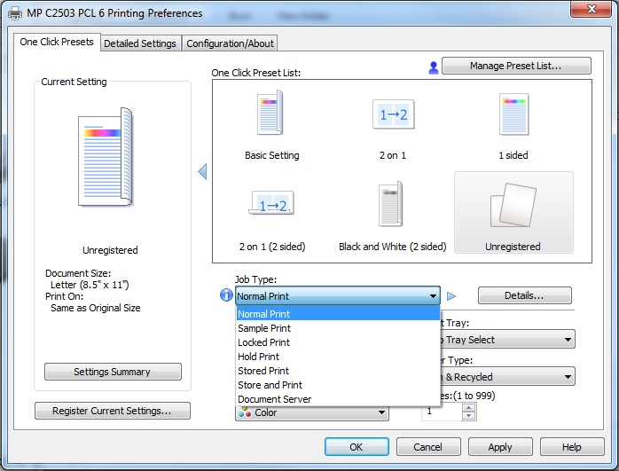

- The Detailed Settings tab is where you can get into more in depth settings of your print job. This tab has sub menus labeled: Job Setup, Basic, Paper, Edit, Finishing, Print Quality, and Effects. The Job Setup sub menu has the same settings as covered in the previous step.

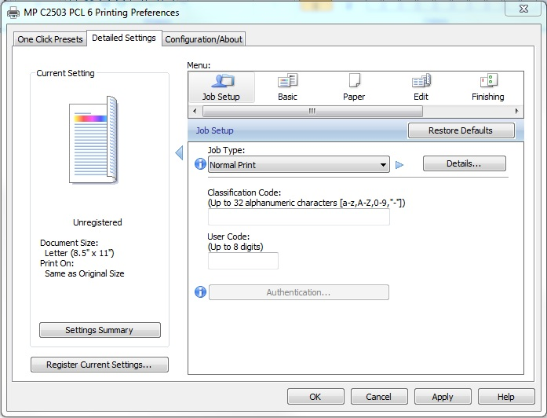

- The next sub menu is the Basic menu is where you can change your Orientation, Color/B&W, Copy amount, and Document Size just like the original One Click Presets tab. This sub menu also adds the Reduce/Enlarge option for your document.

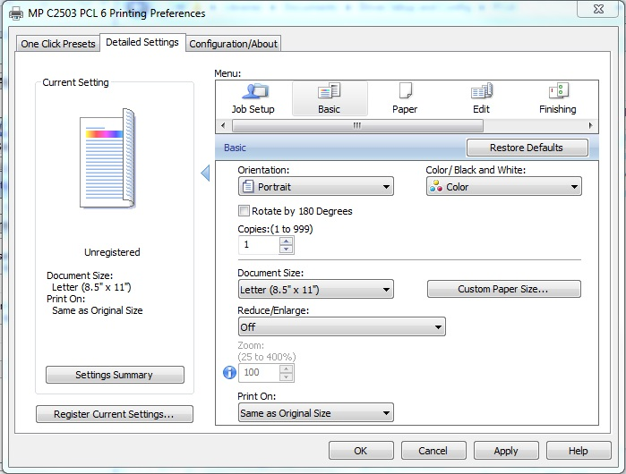

- The next sub menu is the Paper sub menu. In this menu you can change your tray options, paper types, and output tray selections. Furthermore, you can change Banner Page options, Front Cover options, Back Cover options, Slip Sheet options, and Chapter Page options as you scroll down. There are paper stack graphics that will help you visualize the changes you are making when the settings are changed.

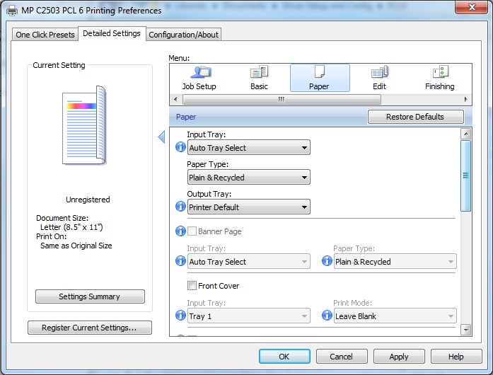

- The sub menu found next is the Edit sub menu. Here you can change the number of pages per sheet under the Layout menu, adjust the order of those pages under the Page Order dropdown menu, set your duplex (or 2 sided) settings, and set any booklet or poster settings. Keep in mind that any changes you make to these settings will be reflected in the page graphic on the top left of the window.

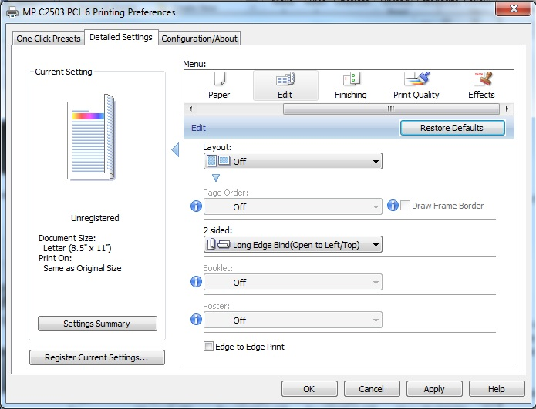

- The sub menu that comes next is the Finishing sub menu. This menu lets you set finishing options such as stapling, hole-punching, and folding depending on your attached finisher. In addition, this is where the collating settings are changed. You can also tell the MFP to rotate the collated copies if your trays are set up for it.

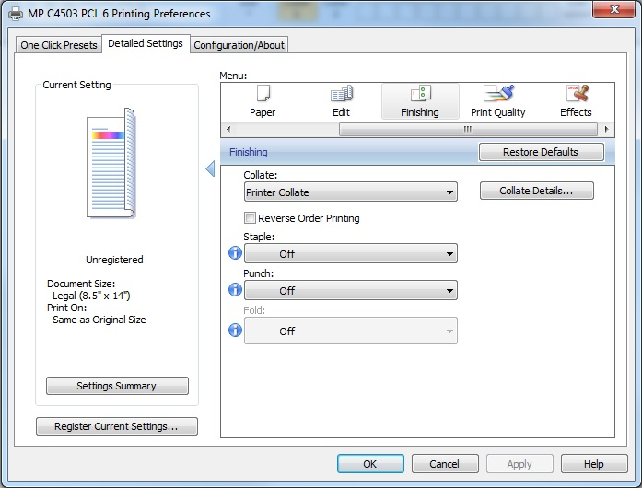

Note: Make sure you have gone to the Printing Properties option for your printer from the Devices and Printers window. (See Step 1) Once into this window click the Accessories tab, see that all your finishers/trays are checked, and then click the Update Now button at the bottom.

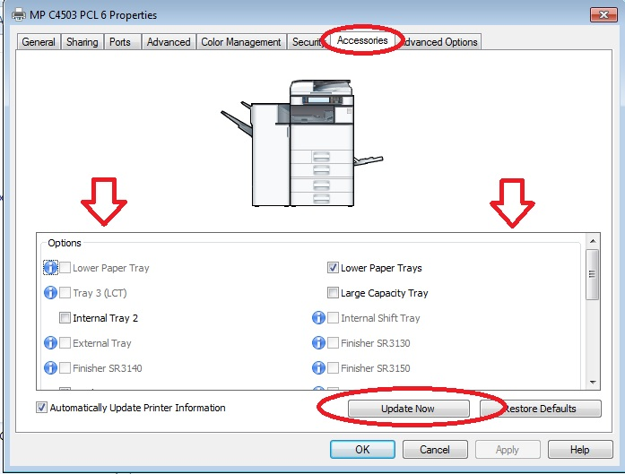

- The next sub menu is the Print Quality sub menu. From this menu you can change the dithering, color profile, and gray reproduction settings. In addition you can set your resolution and vector or raster settings. Keep in mind that image quality will increase at better resolutions at the expense of more toner usage. Finally this menu will allow you to balance your color over the whole document or a single component.

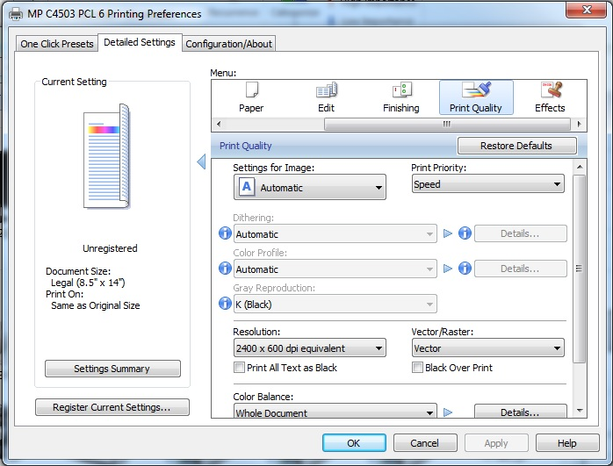

- The final sub menu is the Effects sub menu. This is where you can add and configure watermarks and include the unauthorized copy prevention feature. The default watermark list includes: Confidential, Urgent, Draft, Original, and Copy. You can add a custom watermark and/or adjust font, font style, color, position, angle, and location and centering options by clicking the edit button. The Unauthorized Copy Prevention feature allows users to discourage unauthorized copies of documents by adding text and/or masks to the document. These settings can be fine-tuned by clicking the details button.

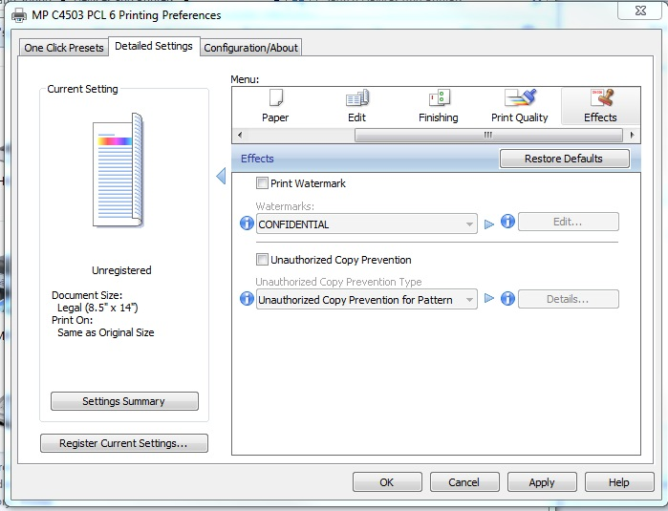

- The final tab of the PCL6 Driver window is the Configuration/About tab. Here you can configure your default view for the whole driver. The Default Tab menu lets you choose between the One Click Presets, Detailed Settings, and Configuration/About tabs as default view. Similarly you can choose which sub menu is viewed first as default in the Detailed Settings tab. Finally you can choose the layout of your one click presets, either icon or list view. The most important feature of this tab is the Web Image Monitor… button in the bottom right. This button will take you to the Web Image Monitor to view and adjust your MFP’s settings. Previously this was accessed by typing the MFP’s IP address into your web browser.

